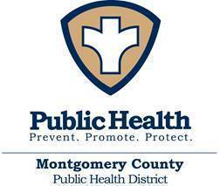

Date: 8/7/2020

MONTGOMERY COUNTY COVID-19 UPDATE
MONTGOMERY COUNTY – Montgomery County Public Health District, in conjunction with the Montgomery County Office of Homeland Security and Emergency Management, can sadly confirm five additional deaths related to COVID-19, bringing the total to 82.

- A woman in her 70s, from Magnolia, died in the hospital. She had co-morbidities in addition to testing positive for COVID-19.
- A woman in her 90s, from Porter, died in the hospice care. She had co-morbidities in addition to testing positive for COVID-19.
- A man in his 50s, from Porter, died in the hospital. He had co-morbidities in addition to testing positive for COVID-19.
- A man in his 50s, from Conroe, died in the hospital. He had co-morbidities in addition to testing positive for COVID-19.
- A man in his 60s, from Porter, died in the hospital. He had co-morbidities in addition to testing positive for COVID-19.

We offer our condolences to all of the families at this difficult time.

- TOTAL cases of COVID-19 increased by 67 to 6,577 since yesterday’s report.
- ACTIVE cases of COVID-19 decreased by 87 to 1,836 since yesterday’s report.
- 53 residents are known to be in the hospital, as a result of contact investigations. Contact investigations have not been initiated on all reported cases.
- 4,487 people have clinically recovered.

The next update will be Monday, August 10th.

Have questions? Please go to https://mcphd-tx.org/ and scroll down to the FAQs.

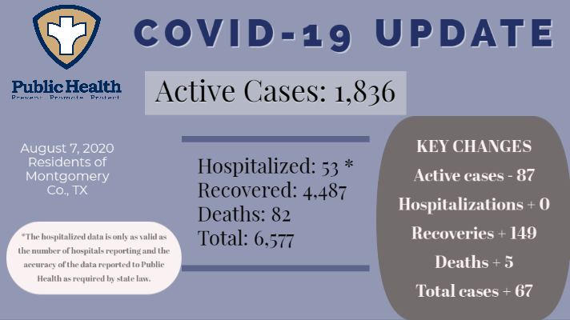
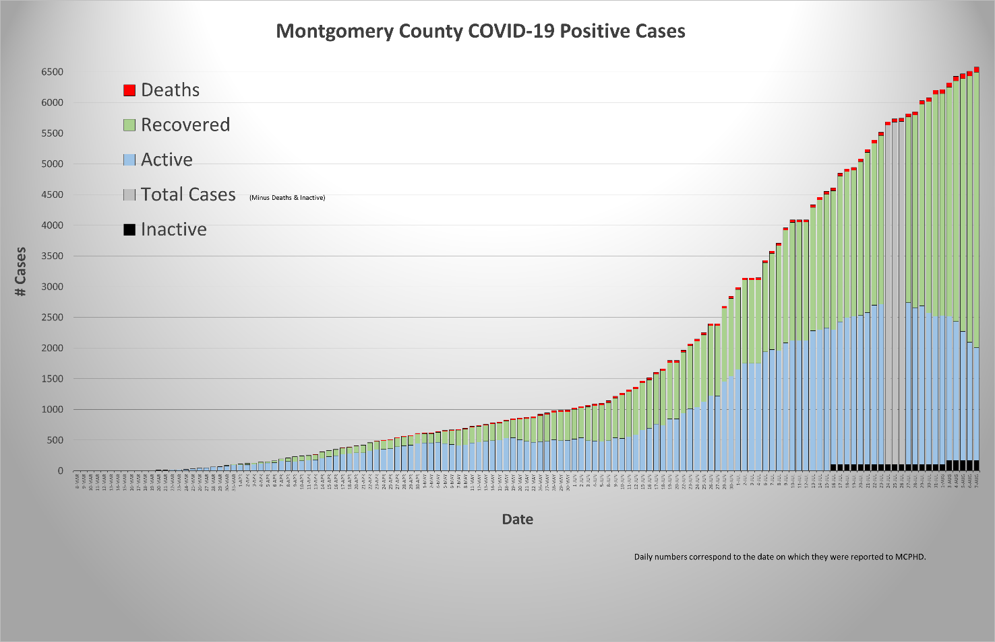

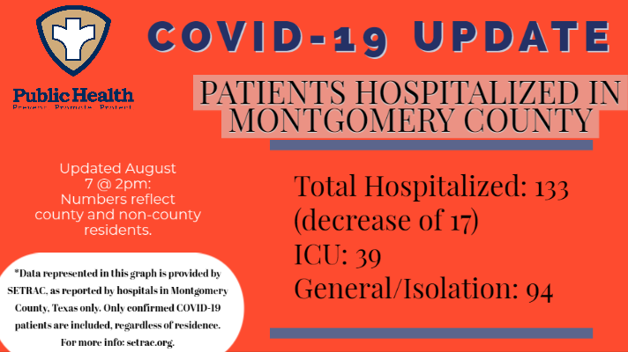
You can find more information on the SETRAC website, setrac.org.

Take steps to slow the spread of COVID-19 in our community.

- Consider staying home unless it is necessary to leave your home.
- Avoid groups of people.
- Practice social distancing.
- Wear a mask (if it is necessary to leave your home).
- Wash your hands or use hand sanitizer frequently.
- Disinfect surfaces in your car and around your home.

You can view the list of case-by-case updates on the MCPHD website here: https://mcphd-tx.org/coronavirus-covid-19/confirmed-cases/. You can refer to the dashboard here: https://coronavirus-response-moco.hub.arcgis.com/.

Just a reminder, online registration is now available for COVID-19 testing through the MCPHD/MCHD voucher program. Click on “Need to be tested?” on mchd-tx.org or mcphd-tx.org and follow the instructions. The COVID-19 Call Center’s number is 936-523-3916. It is open Monday-Friday 8:00am-4:30pm.

Montgomery County Public Health District’s mission is promoting a healthy, resilient community through health education, disease prevention, clinical services, and emergency preparedness. For more information about the Montgomery County Public Health District please go to www.mcphd-tx.org.

